
OVERVIEW
A protocol for issuing a collateralised token
with a monotonically rising mint price

Version 2.2 · a short reading of the white paper
3 September 2026 · assetrix.org

This overview omits nothing and hides nothing. It is shorter than the white paper, not lighter: every mechanism named here is set out in full in the white paper, and the white paper is published at the same time and at the same address. Where the two differ, the white paper governs.

What this is
Assetrix is a protocol for issuing a collateralised token whose creation price rises monotonically and never falls. External assets are placed into a wrapper, entry into which becomes more expensive with every token issued.
The founders regard this as a distinct class of crypto asset, which may be termed a ratchet — a coin with a rising issuance price. The definition refers solely to the price of creating new tokens, which is set by the protocol and does not decline. The market price of ASTRX has no bearing on the definition: it is determined by demand, is not guaranteed by the protocol and may fall.
The class is conceived as a complement to the stablecoin. A stablecoin holds its face value and with it loses purchasing power; here the entry price is tied to a rising quantity, while the collateral remains real and reclaimable at any time.

Position and token
A participant deposits collateral and receives a position — a non-fungible token holding its own collateral. The position may be redeemed at face value, or closed, which issues transferable ASTRX tokens backed by a share of the shared pool.
The distinction matters more than any other in this document. A position entails no nominal loss under any circumstances: the deposited collateral is returned in full, and the cost of holding it is the opportunity cost of capital rather than the risk of loss. A token carries market risk: its price may fall towards the lower boundary of the corridor. Saving without market risk is afforded by the position; the token is suited to payments and to trading.
The protocol is non-custodial. Collateral is held in the smart contract and may be reclaimed by its owner at any time. Collateral is exogenous — the backing consists of external assets rather than the protocol’s own token, so no mechanism for self-destruction of the reserve exists. In this the design differs fundamentally from algorithmic ones.

The price corridor
The protocol does not set the market price of ASTRX and cannot set it. It sets two other figures, and the market price lies between them.
Below sits the backing — the share of the reserve that falls to one token. This level is held up by redemption, which is open at all times: a holder exchanges tokens for a proportional share of the reserve, less the redemption fee, whenever he likes. This is not an undertaking to buy the token back at some price, but a consequence of the design — the reserve belongs to the holders, and the way out of it does not close under any circumstance.
Above sits the cost of entry — the price at which the contract mints a new token. Anyone may enter at any time at that price, so there is no reason to pay substantially more on the market than entry costs.
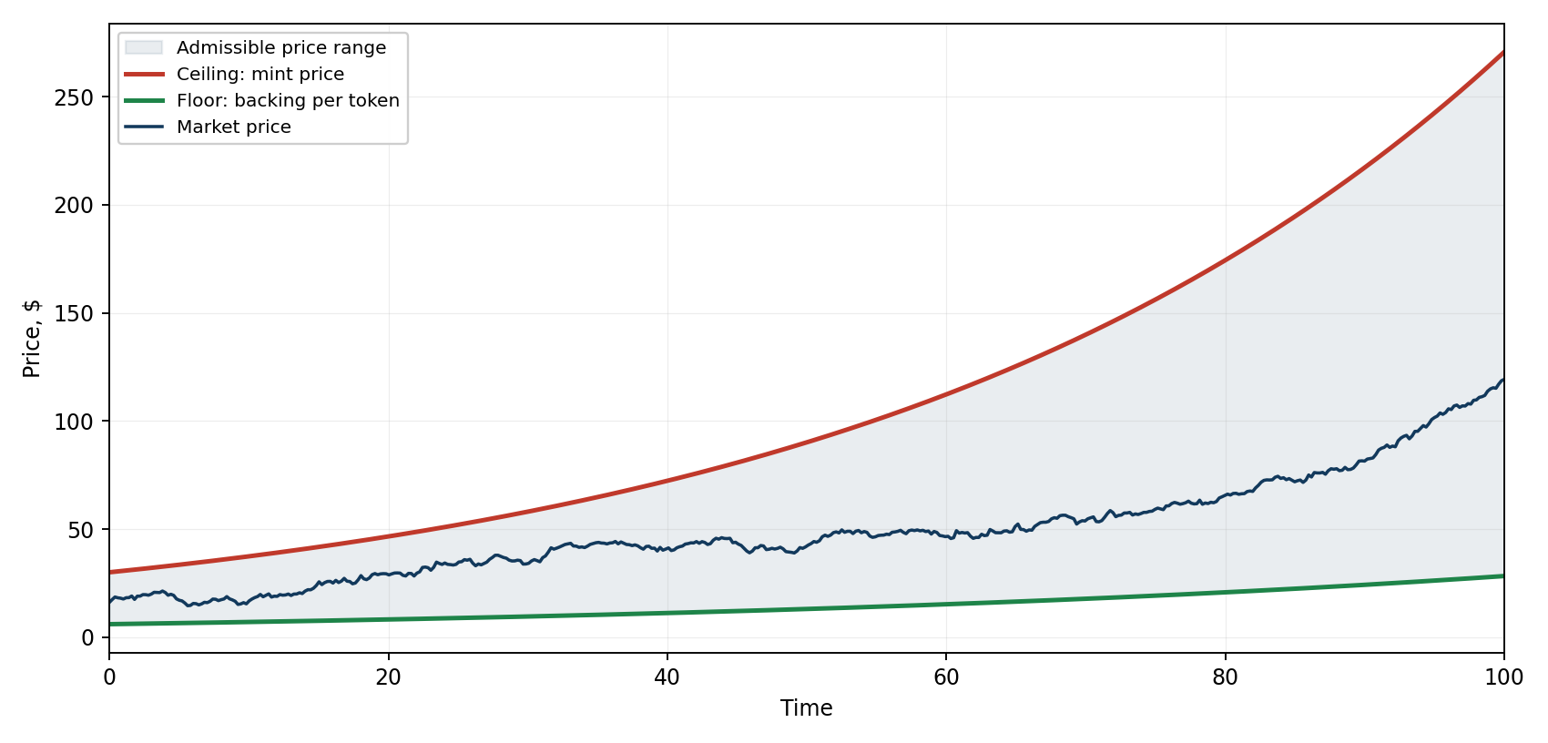
Fig. 1. The price corridor. Both boundaries are maintained by arbitrage.
Where the price sits inside the corridor is settled by the market, and the protocol does not interfere with it.

How the cost of entry rises
In Phase 1 the mint price is defined analytically and depends solely on the number of tokens already issued, running from $0.001 for the first token to $200 for the hundred-millionth. The count covers every token ever created; redemption does not reduce it, so the mint price does not fall under any outflow of participants.
Phase 1 need not run to the hundred-millionth token. From the completion of stage 3 the holders may vote, in any cycle, to end Phase 1 early and move to Phase 2 — the protocol’s main route. Waiting for the curve to be exhausted is not required.
In Phase 2 the mint price becomes a function of time and is recomputed continuously, in accordance with the prevailing growth rate. The rate takes values from a fixed ladder: 5.6, 9, 14.5, 23.6, 38.2, 50, 61.8, 100 and 161.8 per cent a year. The minimum never becomes negative.
Which rung is in force is decided in one of two modes. In automatic mode the rung is moved by the regulator. The regulator is not a body, an office or a person: it is a rule written into the contract. It watches a single indicator — the inflow of collateral into new positions over each cycle of about forty-one days — and does nothing while the inflow stays within its usual variation. When the inflow falls by more than that, the rule steps through the ladder from the current rung, one probe per cycle, until it finds a rate at which inflow resumes; it keeps no memory of which direction helped last time. In manual mode the regulator is switched off and the holders set the rate directly by vote, the median of the votes prevailing.
The choice of mode is itself a vote, open in every cycle. Switching is reversible and may be repeated any number of times: the community may hand the rate to the rule, take it back, and hand it over again. One exception exists. If the regulator has tried every rung and inflow has not recovered, the contract itself sets the lowest rate and passes control to the holders — a finding, not a fault: inflow is falling for reasons the rate cannot fix.
Both figures — two hundred dollars and 161.8 per cent a year — are ceilings on the cost of entry, not a return. They describe how fast entry into the protocol may grow dearer, and say nothing about what a holder will receive. The formula is disclosed in full and deliberately so: the mint price is computed by the contract and is reproducible from the bytecode in any event.

What pushes the corridor upward
Two figures in the protocol move only in one direction: the cost of entry, always; and the backing per token, so long as the reserve consists of stablecoins. The market price is not one of them — it is bounded by them. What follows is the list of mechanisms by which the two boundaries are raised and defended. Each is implemented in the contract, none depends on anyone’s goodwill.
The ratchet. The mint price never falls. The issuance count that drives it includes every token ever created and is not reduced by redemption, so no outflow of participants makes entry cheaper for those who come later than it was for those who came before.
Closings that raise the floor. When a position created at a high mint price is closed, its collateral joins the pool at a price above the current backing, and backing per token rises for everyone. This is the principal channel of growth. Such a closing is never charged a fee — the rule is outside the reach of any vote — and it is rewarded with voting credits equal to the tokens received.
Fees that flow to the holders, not to the project. The dilution fee on a closing that would lower backing is withheld in tokens that never enter circulation. The transfer fee and every token burned to cast a vote leave the supply while their collateral stays in the pool. The redemption fee stays in the reserve. These channels work counter-cyclically: they are strongest precisely when participants are leaving, so the backing of those who remain rises when the market is weakest.
The redemption multiplier. The redemption fee is multiplied by a factor that grows with the drawdown of backing from its historical maximum — 1 at no drawdown, 1.618 at 38.2 per cent, 2.618 at 61.8. The factor is continuous, so there is never a moment before which it pays to hurry out, and it returns to one by itself as backing recovers. Its purpose is to keep the pool’s volume through a drawdown, which makes every later dilution smaller in proportion.
The protection level. Backing per token is not permitted to fall below a share of its historical maximum — 61.8 per cent by default, adjustable by vote within a fixed ladder. A closing that would dilute the pool may use at most 38.2 per cent of the headroom above that level, so the remainder shrinks geometrically and the level is approached but never breached. No sequence of operations, no number of addresses and no splitting of positions changes this.
Redemption is neutral. A holder who redeems takes exactly his proportional share of the reserve. The pool shrinks; the backing of those who remain does not. A collapse of backing through exit is impossible by construction.
Surcharges on volatile collateral. A deposit in a volatile currency pays a spread, and a further surcharge when that currency’s share of the reserve is high. Both enter the pool without creating new tokens, so they raise backing for everyone.
Rounding and arbitrage. Every rounding in every operation goes the way that is safe for the reserve. And the corridor itself is held by arbitrage without any action by the protocol: above the cost of entry, minting is cheaper than buying; below the backing, redeeming is better than selling. The market price is kept between the two by whoever notices first.
What none of this protects against is a fall in the price of the collateral itself. Where participants deposit volatile currencies, the floor holds backing relative to the reserve, and the reserve is measured in what sits in it: the asset falls, and the level below which the protocol will not let backing go falls with it. The spread, the surcharge and live valuation soften this; they do not remove it.

Governance
The protocol’s parameters are governed by holders themselves. Subject to a vote are the fees that flow into the shared pool and work for the voters, the depth of backing protection, the method of returning funds, the set of collateral currencies, the rate of increase of the issuance price and the mode of its regulation, and the moment of completion of the first phase. No protocol role can alter these values against holders’ will, admit a collateral currency contrary to their decision, or halt the return of funds to participants.
The volume of issuance is regulated differently — not by vote but by participants’ own decisions. The protocol issues no tokens at its own discretion: every token is created by whoever deposited collateral and disappears when someone reclaims it. The money supply follows market need directly, without an intermediary deciding on others’ behalf.
The contract is immutable and is deployed on Arbitrum One.

What the protocol does not do
The protocol creates no income from nothing and pays no interest. Collateral comes solely from participants, while growth in backing per token arises from fees and from the closing of positions created at a higher price. The protocol generates and promises no passive income.
It does not guarantee, support or target the market price of ASTRX. It does not undertake to buy tokens back at any particular price. It does not protect the value of volatile collateral. And it does not forecast: the foregoing describes intent and mechanics, and the market’s actual behaviour depends on circumstances beyond the protocol’s control.

Where to read the rest
This overview covers what the protocol is and how its principal mechanisms fit together. It does not cover the shape of the curve within a stage, the schedule of fees, the arithmetic of the regulator’s dead band and search order, voting credits and their depletion, the admission and suspension of collateral currencies, oracle handling, or the behaviour of the system under loss of reserve. All of these are set out in the white paper, in full and with the formulas.
White paper, protocol specification and official links: https://assetrix.org

Verification
A SHA-256 checksum and an OpenTimestamps proof are published for this document and for the white paper. The checksum establishes that the file you hold is byte-for-byte the one released; the timestamp, anchored in the Bitcoin blockchain, establishes the date on which that exact file existed. Neither requires trusting this project.
Checksums and timestamp proofs for this document: https://assetrix.org/documents
The timestamp proof is distributed as a separate .ots file alongside the document, since a file cannot contain its own checksum.

assetrix.org — official website

Disclaimer
This document describes the protocol’s design and does not constitute an offer to acquire any asset, investment advice, or a promise of return. ASTRX is not an investment product. Figures quoted were obtained from a model and rest on stated assumptions; actual values will differ.
Verification carried out to date. The tokenomics have been modelled in a reference implementation independent of the contract, under a range of holder behaviours: steady inflow, stagnation, mass exit, and deliberate attempts to dilute the pool through splitting and multiple addresses. In every scenario modelled, backing per token held above the protection level and rose over the run. The contract code is covered by a test suite that reproduces the reference implementation’s results and exercises the failure modes the design anticipates: stale or unavailable price feeds, a halted L2 sequencer, loss or de-pegging of a reserve currency, and rounding under adversarial input. Each has a defined response in the code. These are the project’s own tests; they are disclosed so that they can be repeated, and they precede rather than replace review by others.

