
PERIPHERY
Appendix to the White Paper 2.6
The router, the reader and the position manager for Uniswap v4
Version P1.0
15 September 2026 · assetrix.org
Prepared by Assetrix DAO Research Group

Contents
Part I
1. What this appendix is
2. Why anything is needed at all
3. The router
4. The reader
5. The position manager for Uniswap v4
6. What the periphery has been checked by
7. Where the code and the addresses are
Part II — Corrections to the White Paper 2.6
How this list came about
1. How low the operator may set the protocol fee
2. When the early vote on Phase 2 opens
3. What the regulator skips when a currency leaves
4. How long a stablecoin keeps its par
5. Three subjects missing from the table
6. Votes on Phase 2 subjects cast in Phase 1
7. Whether redemption reads quotes
Two borderline points
The cost of operations, section 12.4
Part III — Technical annex
1. The router: functions
2. The router: refusals
3. The reader: functions
4. Build and fingerprints
5. Tests
6. Where to verify
Disclaimer
Verification

Part I

1. What this appendix is
The White Paper describes the protocol: the core contract, its modules, and the rules they enforce. This appendix describes what is published alongside the protocol without being part of it: a router for Uniswap, a reader for the protection gate, and the position manager for Uniswap v4 that is planned but not yet written.
Who needs this and who does not. The router is for those who take ASTRX to a decentralised exchange while the transfer fee stands above zero: liquidity providers on Uniswap first of all, and anyone selling ASTRX there. The reader is for a holder who wants to know in advance how much of a position the protection gate will let him close. Minting, redeeming, closing a position, transferring tokens and voting go through the core alone and need none of it; the reader only says beforehand what the gate will answer. A holder who never touches Uniswap and never asks that question can put this appendix aside; nothing in the protocol depends on it.
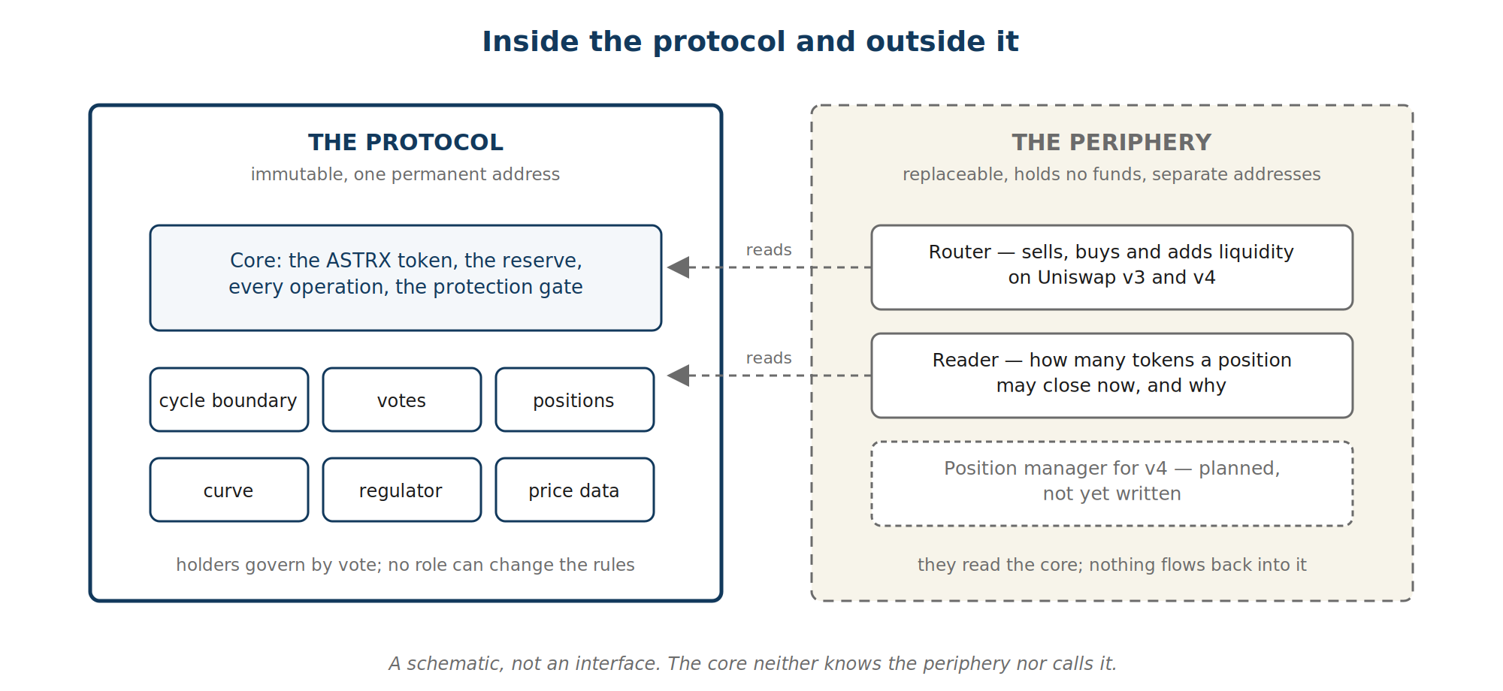
Fig. 1. Inside and outside the protocol: the core and its modules on one side; the router, the reader and the planned manager on the other, with no arrow from them into the core. A schematic, not an interface.
None of these holds any right over the core. The core does not know them, does not name them and does not call them. Anyone who writes better ones may replace them, and the protocol goes on unchanged. That is why they are described here and not in the White Paper: the White Paper is the account of what cannot change, and this appendix is the account of what can.
The White Paper governs on any question about the protocol. This appendix governs on any question about the periphery. Part II lists the places where the White Paper 2.6 describes the protocol differently from what the code does; in each of those places, this appendix states which is right and why, and the White Paper itself is not altered.

2. Why anything is needed at all
While the transfer fee stands at the bottom rung of its ladder, which is zero, ASTRX moves like any other token and the router is not needed. Everything said about the router concerns what changes if the holders vote the fee above zero.
Above zero, every transfer of ASTRX burns a share on the way. A pool on a decentralised exchange does not look at what reached it. It names a figure and requires its own balance to have risen by at least that much. Hand it exactly the figure it named, and part of the sum is burnt before it arrives; the pool comes up short and refuses. Neither side is wrong. The pool counts correctly and the token behaves as described. They simply cannot settle with each other directly.
The way through is to send enough for the named figure to arrive after the burn, and to know in advance how much that is. The router does exactly that, and nothing else.
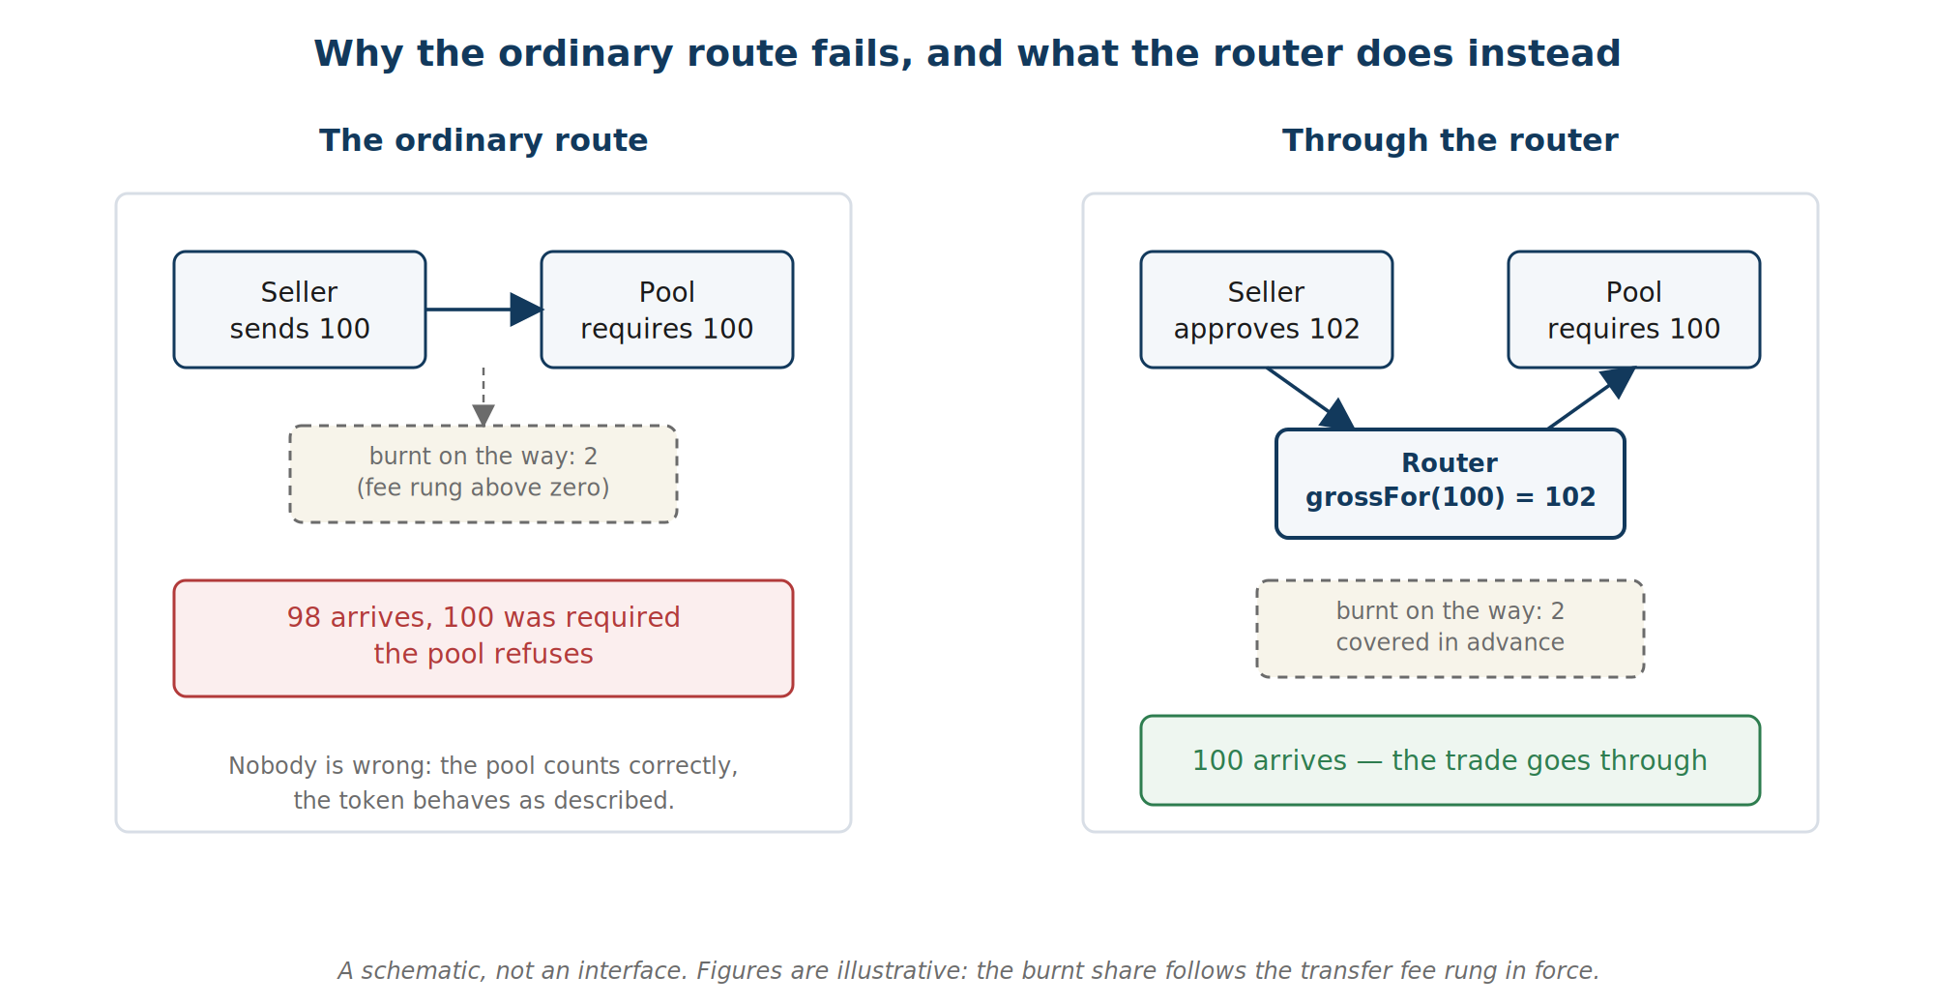
Fig. 2. Why the ordinary route fails and how the router closes the gap: the figure named, the share burnt on the way, the gross the router sends. A schematic, not an interface.
The reader exists for a different reason, and it begins with the protection level.
The core guards backing per token against being diluted by cheap positions. Backing has a record, a figure that never falls. Below the record lies the protection level, which the holders set by vote — 23.6, 38.2, 50 or 61.8 per cent — and the record reduced by that level is the threshold. A position bought cheaply brings many tokens into circulation against little collateral when it closes; let enough of them close at once and backing per token would fall through the threshold. With the level at 61.8 per cent, for example, the holders have decided that backing may not be diluted deeper than 61.8 per cent below its record, and the core refuses any closing that would take it there. A position whose cost basis stands above the threshold meets no gate. A position below it passes only in a volume that leaves backing above the threshold, and a single closing takes at most 38.2 per cent of the headroom that remains.
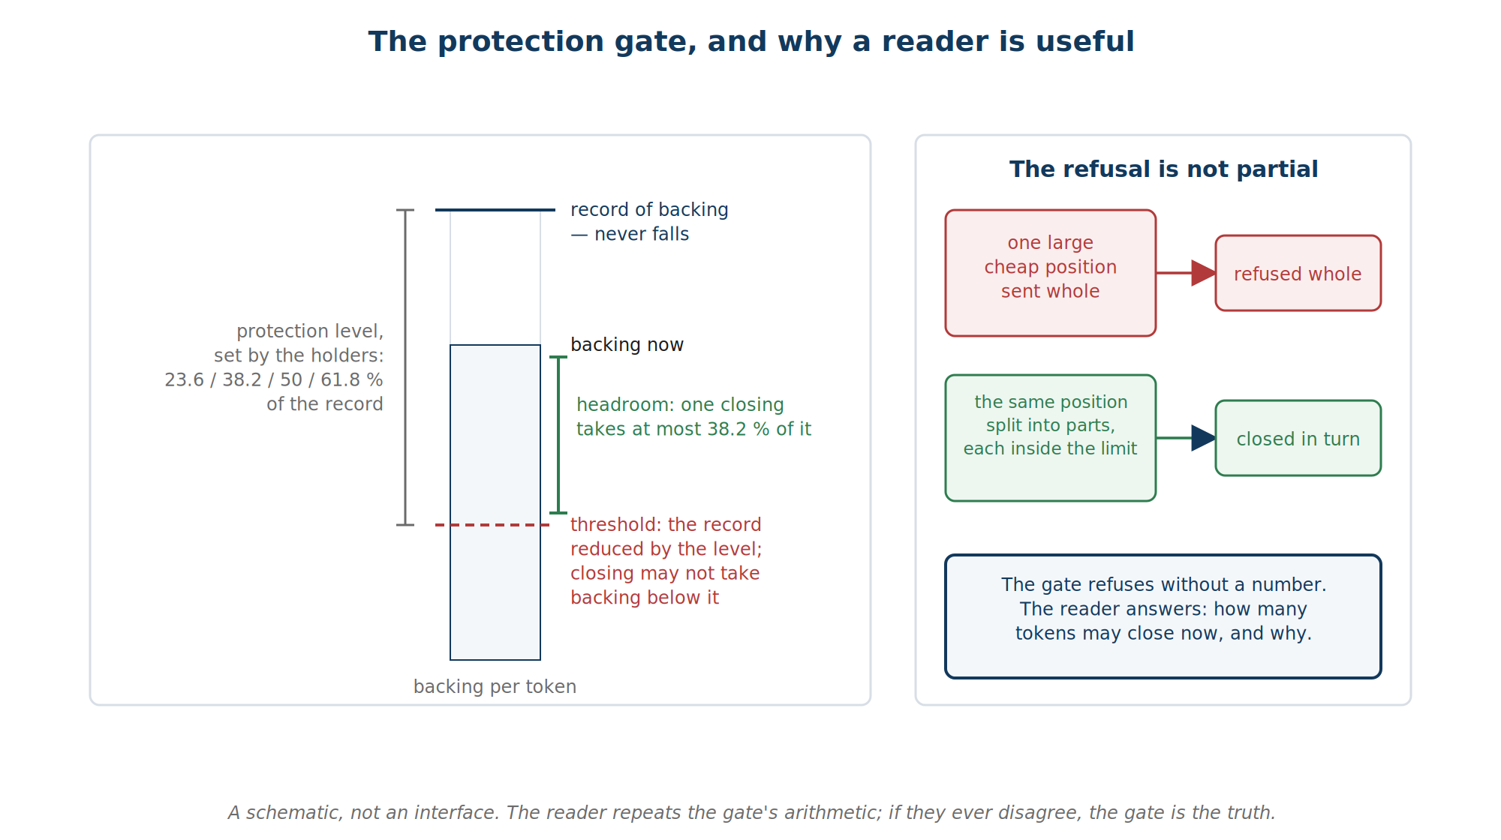
Fig. 3. The protection gate: the record of backing, the level chosen by vote, the threshold, the headroom, and the share of it one closing may take; a position refused whole and the same position split into parts. A schematic, not an interface.
The refusal is not partial. A holder of one large cheap position who sends the whole of it to be closed does not get the permitted part closed and the rest refused: the whole is refused. To take what the gate allows, the position is split and closed in parts. And the gate says nothing when it refuses — no figure, only the refusal. The arithmetic behind the figure is public, but working it out takes a reader of Solidity an evening. The reader does that evening's arithmetic once and answers with the number and the reason.

3. The router

3.1. What it does
The router carries ASTRX into and out of Uniswap, on v3 and on v4, and adds liquidity on v3. It has six doors:
- sellV3 and buyV3 — a trade on a Uniswap v3 pool, named by its address;
- sellV4 and buyV4 — a trade on Uniswap v4 through the singleton, the one contract that holds every v4 pool; the pool is named by its key, the set of parameters that identifies it;
- sellV3WithPermit and sellV4WithPermit — the same two sales, with the approval given by signature, so that a sale is one transaction instead of two.
A seventh function, addLiquidityV3, opens a liquidity position on a v3 pool. One more, grossFor, is a public calculation that anyone may call: how much must be sent for a given amount to arrive at a given fee rung. That one function is the whole of the arithmetic the router adds, and it can be checked from outside.

3.2. What it does not do
The router holds nothing. It keeps no balance between calls, has no owner, no settings and no upgrade path. It carries no right over the core: it cannot mint, cannot close a position, cannot touch the pool of collateral, and the core does not know it exists. A better router can be written by anyone and used in its place. The address of the router is therefore published separately from the address of the core, and it may change; the address of the core cannot.

3.3. How a sale goes through
On v3, the router tells the pool the smaller figure — the amount that will actually arrive — and hands over enough for it to arrive. On v4 the order is reversed: the router pays first, the singleton credits what arrived, and the swap is made for exactly that. In both cases the seller names what leaves his balance, the burnt share included. That is the figure he approves, and the figure the router will not exceed.
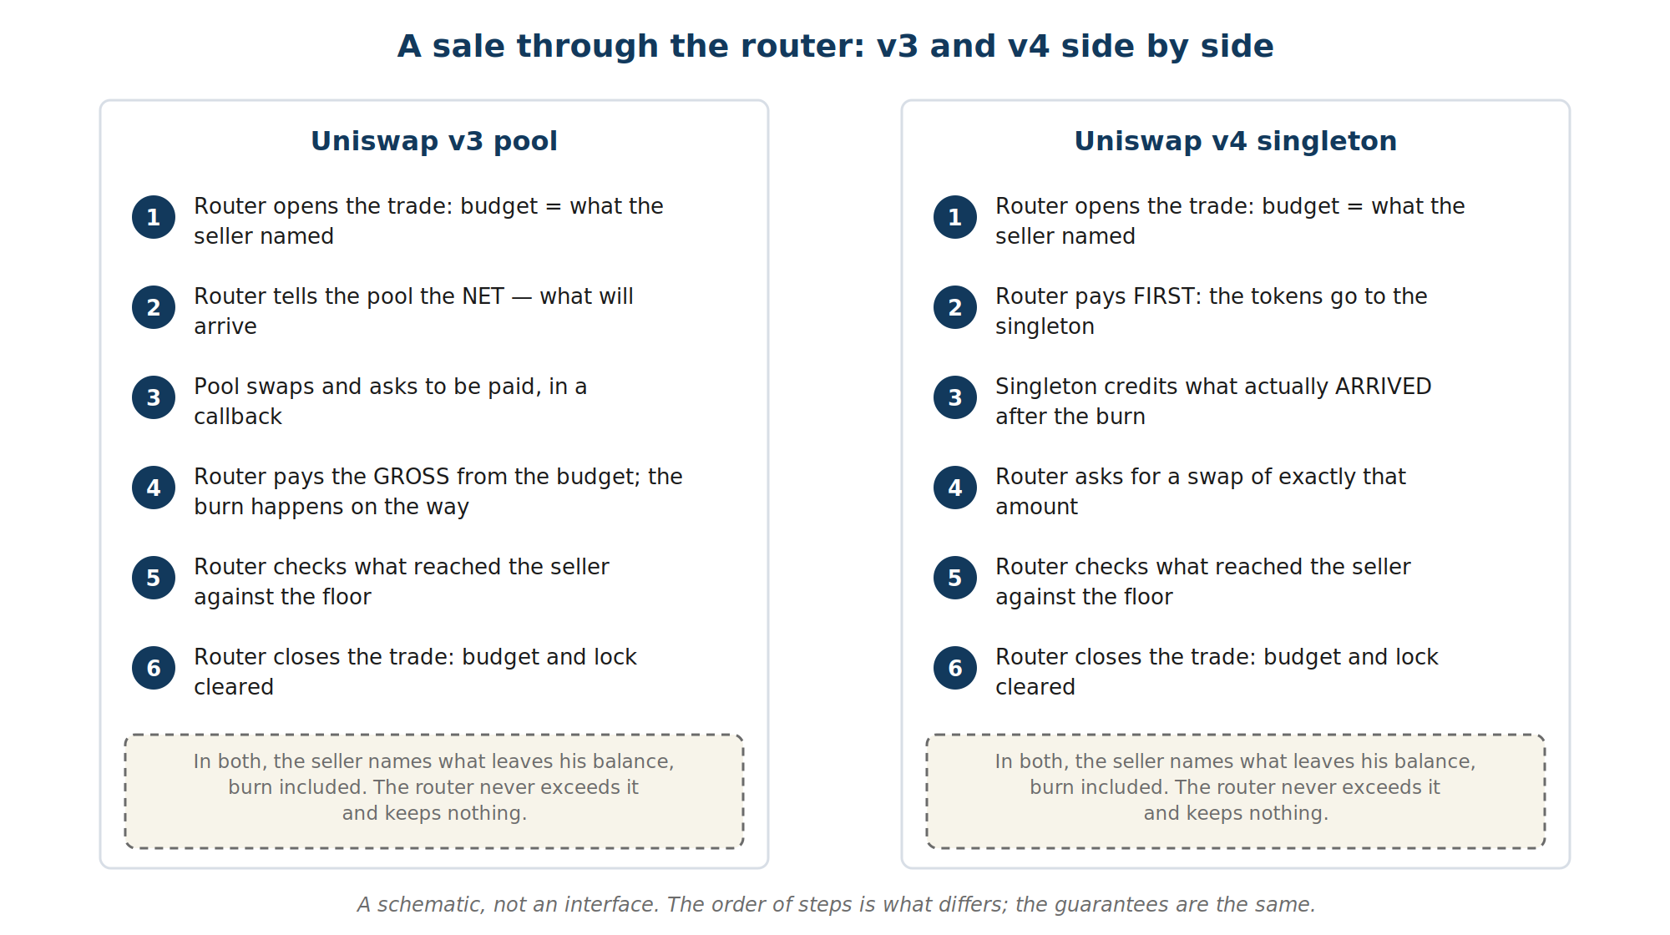
Fig. 4. A sale through the router, v3 and v4 side by side: on v3 the pool is told the net and paid the gross; on v4 the payment goes first and the swap is made for what arrived. A schematic, not an interface.
Buying needs no compensation. What goes in is an ordinary token, and the ASTRX comes out through a transfer like any other, so the buyer receives slightly less than the pool sent. The router measures what actually reached the buyer, not what the pool reported, and it is against that measured figure that the buyer's floor is checked.

3.4. How it protects the person using it
Every door checks the same things before it opens, and refuses with a named reason rather than a silent failure.
- The deadline. A trade named for a moment that has passed is refused.
- The pool. A v3 pool is accepted only if the canonical Uniswap factory names that very address for that pair and fee. A contract that merely looks like a pool is refused before anything is paid. On v4, the singleton's address is fixed at deployment and cannot be swapped.
- The lock. While one trade is open, no other door of the router opens. A pool or singleton that tries to walk back into the router mid-trade is refused. The lock is released when the trade ends, and the next trade may follow in the same block.
- The budget. A trade is opened with a budget: the amount the trader named, and not one unit more. The pool may ask to be paid only inside that budget, and the budget is spent as it is paid, not merely checked. A pool that asks for more than was offered is refused; a pool that asks twice finds nothing left.
- The floor. A sale or purchase that would deliver less than the floor the trader named is refused. Output exactly on the floor is accepted. A swap that moved nothing at all is refused even when no floor was named, so that nobody pays for a transaction that reported success and delivered nothing.
- The recipient. Proceeds cannot be sent to the zero address or to the router itself.
- The shortfall. If a token delivers less than it promised, the router tops the payment up once, from the same budget; if the shortfall cannot be closed, the trade is refused rather than settled short.
The signature in the two permit doors is attempted rather than required. A signed approval sits in the open before it is mined, and anyone may spend it first at no cost. A sale that insisted on spending it itself could be stopped by a single cheap transaction; a sale that merely tries it goes through either way.

3.5. Liquidity
On v3 the pool asks whom a position should be credited to, and payment comes afterwards, in a callback — a call the pool makes back into the router to collect what it is owed. The router names the depositor as the owner from the first moment and pays the compensation itself. A range placed above or below the current price is owed on one side only, and the router pays only that side. Taking liquidity back needs no router: the pool hands it to whoever owns the position.
On v4 the arrangement is different, and it is the reason a position manager of Assetrix's own is planned. Section 5 says what the White Paper says about it, and no more.

4. The reader

4.1. What it answers
For one position, the reader answers three things: how many tokens the protection level would let that position close right now; why the answer is what it is; and whether a cycle boundary is waiting to be settled, in which case the real close will settle it first and the limit may move.
The reason is one of eight. The position is above the threshold and faces no limit. The position is limited and fits inside the limit. The position is limited and is larger than the limit. The pool sits on its floor and nothing dilutive closes. The limit is under one token and nothing closes. The position's currency has no live quote. The currency is barred. The position is empty.

4.2. What it is and what it is not
The reader is outside the protocol. It holds no funds, keeps no state, is not called by the core and cannot change anything. It reads the core through public views only and repeats the gate's arithmetic line for line, rounding included. If the two ever disagree, the gate is the truth and the reader is wrong.
It reads quotes. It therefore gives no answer when the sequencer is down, exactly as the core's own view of backing gives none. Redemption never needs it: redeeming a position reads no quotes and passes no gate.

5. The position manager for Uniswap v4
The White Paper says this, and this appendix repeats it without adding to it.
Uniswap v4 does not ask whom a position belongs to; a position belongs to whoever opened the lock, and Uniswap's own position manager keeps the positions and issues each depositor an NFT. That manager names an exact figure and moves it itself, letting nobody in while it holds the lock. With a burn on transfer, less arrives than was named, the debt to the pool stays open and the operation fails. This was measured on the live network, not argued: at the zero rung the deposit goes through, above it the same deposit is refused.
Assetrix therefore plans a position manager of its own, on the same model as Uniswap's and with one difference: it covers what is burnt. It will open the lock, settle with the compensation, and issue the depositor the same kind of NFT. It is not written yet. Until it exists, liquidity on v4 is added through the ordinary Uniswap interface while the transfer fee stands at zero. When it exists, it will be described in a later version of this appendix, and its address will be published alongside the router's.

6. What the periphery has been checked by
The figures below are as of build 20 of 15 September 2026. They are the results of checks, not promises about the future.
The router is exercised by fifty-eight tests. Twenty-seven of them run against the live Uniswap deployments on Arbitrum One, in a private copy of the network's state taken at the moment of the run; thirty-one run locally against stand-ins that play the pool and the singleton from the other side of the wire. Every refusal named in section 3.4 has a test that provokes it, and for every refusal there is also a test in which the same door accepts the trade — so a refusal is the guard working, not the path being broken.
The router was then put through a mutation campaign: two hundred and ten small deliberate breakages of its code, each followed by the full suite. One hundred and ninety-eight were caught. Seven did not compile. Five survived, and each is explained: four are changes that no behaviour can show, because the code around them makes the change unobservable, and one would show only if a governance cycle ended in the middle of a trade with the fee stepping down. No breakage found a defect in the router; every one that survived at first was a gap in the tests, and the tests were written for them.
Slither, a tool that reads code for known patterns of risk, raised twenty-eight warnings about reentrancy in the router — the risk of a contract being re-entered mid-operation. Each was examined one by one, and none is a defect. Nine are the measure-before-measure-after pattern that a burn on transfer forces; the rest are the lock and the budget themselves, which the tool flags because a lock is closed and a budget is spent after the call they protect — exactly where they must be.
The reader is exercised by fifteen tests, and was put through the same kind of campaign: forty-nine breakages, forty-five caught, one that did not compile, three explained as comparisons that differ only when two quantities are exactly equal. Its arithmetic is compared with the core's to the last unit, with a currency dark and with positions forged to exactly the limit and one grain over.

7. Where the code and the addresses are
The code of the router and of the reader is published in the protocol's repository, in the same source tree as the core, with the same pinned compiler and the same reproducible build. Their fingerprints are listed in the technical annex, Part III.
The addresses will be published on the official resources page of assetrix.org once the contracts are deployed: the address of the core on its own, and the addresses of the router and, later, the position manager, separately from it. The address of the core is permanent. The addresses of the periphery may change when a better router or manager is published, and the page will say which is current.

Part II — Corrections to the White Paper 2.6

How this list came about
On 13 September 2026 the White Paper 2.6 was read once more against the code as frozen for deployment. The reading was done by an independent model working from the code and the book alone, and every point it raised was then checked line by line in the code. It raised seven points and two borderline ones. All seven are real. In six of them the book is wrong and the code is right. In one the book was right and the code was wrong; that one was fixed on the same day, before the code was frozen for good.
The White Paper carries a timestamp and is not altered. This part is its list of corrections. Each item says what the book says, what the code does, and which of the two is right. None of them changes the rules of backing, fees or redemption as the book states them; they are details of timing, counting and wording. The specification was brought into line with the code in its version 1.7 at the same time.

1. How low the operator may set the protocol fee
The book says. The operator may set the protocol fee anywhere below the ceiling of the stage, "down to zero".
The code does. Zero has a different meaning. Setting the fee to zero tells the contract to use the ceiling of the current stage. The lowest fee the operator can actually set is one hundredth of one per cent.
Which is right. The code, and on purpose: the comment above the setting says so. The book overstates. An operator who wants the lowest possible fee sets 0.01 per cent, not zero.

2. When the early vote on Phase 2 opens
The book says. Two things, and they do not agree with each other. The table of governed parameters says the vote is available from Stage 3. The text says the reference point is fixed when the issuance counter first enters the fourth stage, and that voting is open from that moment.
The code does. The reference point is fixed when the counter enters the fourth stage. The table's "Stage 3" is a slip of counting: the code numbers stages from zero and the documents from one, and the table used the code's number. Voting then opens not at once but from the next cycle after the one in which the point was fixed. The result, as for every subject, applies at a cycle boundary.
Which is right. The code. The fourth stage, and the cycle after the reference point. The same slip stood in specification 1.6 and was corrected in 1.7.

3. What the regulator skips when a currency leaves
The book says. The cycle in which a currency stopped being accepted is not used as a base for the regulator's comparison. One skip, and only when a currency leaves.
The code does. Two skips, not one. The cycle in which the currency left is spoiled as a measurement, and it would also have served as the base for the next comparison; both are skipped, and the regulator decides again in the third cycle. The skip is set by four events, not one: a currency switched off by vote, a ban confirmed at a boundary, a ban imposed by the operator on a currency still taking deposits, and the removal of the loss flag from a currency that is still active. The last is not a departure at all, but it moves the measured inflow by the same kind of step, so the same two comparisons are unfit.
Which is right. The code. The book counts one skip and names one cause.

4. How long a stablecoin keeps its par
The book says. A stablecoin whose price source has been silent for less than a cycle is valued at par; silent for longer, it goes dark.
The code does. The clock that measures the silence is written no more than twice a cycle, and it is refreshed by any operation that values the pool, not only by a deposit in that currency. Par therefore lasts from half a cycle to a full cycle after the last reading that wrote the clock, not exactly a cycle. The saving is gas, and the price of it is this half-cycle spread.
Which is right. The code. The book gives the upper edge of the range as if it were the whole of it.

5. Three subjects missing from the table
The book says. The table of governed parameters lists ten subjects.
The code does. Holders vote on thirteen. Three are missing from the table: switching a collateral currency off, lifting the loss flag from a currency, and the collateral spread. All three exist, are voted like the others, and are described elsewhere in the book.
Which is right. The book's text; the table is short by three rows.

6. Votes on Phase 2 subjects cast in Phase 1
The book says. The growth-rate control mode and the rate in manual mode are available for a vote from Phase 2.
The code did. Until 13 September 2026 the contract accepted a vote on either of them in Phase 1. The vote burnt the holder's weight, the result was thrown away at the boundary, and the call did not even fail. The backing behind the burnt tokens stayed in the pool, so nothing was lost by anyone but the voter — but the voter lost for nothing, without a warning.
Which is right. The book. The code was corrected before it was frozen: a vote on either subject is now refused until Phase 2, with the same refusal the early-transition vote already gave. The fix and the tests written for it are recorded in the protocol's test results under build 16.

7. Whether redemption reads quotes
The book says. Position redemption makes no reference to quotes, and the plain slice — token redemption — requires none.
The code does. The payout depends on no price, in either case: the same currency and amount come back from a position, and a token holder receives a share of each balance in proportion to the tokens presented. That part is exactly as the book says. But token redemption does read the price feeds in passing, to keep the par clocks of section 4 fresh, and it does not fail when the feeds are down.
Which is right. The substance of the book. Its wording is too strong: redemption depends on no quote, which is not the same as reading none.

Two borderline points
These are not corrections. They are places where the book's words are rounder than the code's numbers.
"$200 for the hundred-millionth token." The curve ends at $200.046. The book rounds.
"The fee accumulates at a single treasury address." There is no separate address. The fee sits on the balance of the core contract itself, and shareholders claim their part from there. The substance — one place, shares, a claim — is as the book says; "treasury address" is a looser word for the contract.

The cost of operations, section 12.4
The gas figures in the book date from before the fixes of September, and the conditions they were taken under are not recorded with them. The figures below are the most recent measurement, with its conditions stated: a rehearsal of the deployment in a fork of Arbitrum Sepolia on 13 September 2026, at live prices, with four collateral currencies. They are measurements, not a comparison made under equal conditions, and they will move again with prices and with the state of the pool.
Operation | The book | Measured, 13 September 2026
Position minting | 545,000 | 691,600
Basket redemption, four currencies | 420,000 | 279,455
Position closing | 335,000 | 291,832
Position redemption | 104,000 | 101,166
Voting | 87,000 | 85,689
Splitting a position into four | — | 609,522
ASTRX transfer | 77,000 | not remeasured in that run

A later version of this appendix will carry the figures from the live network once the protocol is deployed.

Part III — Technical annex
This part is for the reader who wants to check. It names the functions, the refusals and the fingerprints, and nothing that Parts I and II have not already said in plain words.

1. The router: functions
All amounts are in the smallest unit of the token. A deadline is a Unix time; a call made after it is refused.
Trades on Uniswap v3. The pool is named by its address and must be the one the canonical v3 factory returns for its pair and fee.
- sellV3(pool, amountIn, minOut, to, deadline) — sells amountIn ASTRX, the burnt share included, and delivers the paired token to to. Returns the amount delivered.
- buyV3(pool, amountIn, minOut, to, deadline) — pays amountIn of the paired token and delivers ASTRX to to. Returns the amount that actually arrived at to, after the burn.
- sellV3WithPermit(pool, amountIn, minOut, to, deadline, sig) — sellV3 preceded by an attempt to apply the signed approval sig.
- addLiquidityV3(pool, tickLower, tickUpper, liquidity, maxAstrx, maxPair, deadline) — opens a position of liquidity in the range, owned by the caller from the first moment, paying at most maxAstrx and maxPair. Returns the two amounts the pool took.
Trades on Uniswap v4. The pool is named by its key; the singleton's address is fixed in the router at deployment.
- sellV4(key, amountIn, minOut, to, deadline) and buyV4(key, amountIn, minOut, to, deadline) — as on v3.
- sellV4WithPermit(key, amountIn, minOut, to, deadline, sig) — sellV4 preceded by an attempt to apply sig.
Arithmetic.
- grossFor(need, fee) — pure. Returns the smallest amount that leaves at least need after a burn at rate fee, rounding up. This is the only arithmetic the router adds.
Callbacks. Called by the pool or the singleton during a trade, never by a user; each refuses any caller other than the party the router opened the trade with.
- uniswapV3SwapCallback(amount0Delta, amount1Delta, data) — pays the pool what it is owed after a v3 swap.
- uniswapV3MintCallback(amount0Owed, amount1Owed, data) — pays the pool what it is owed after a v3 mint, one side only when only one side is owed.
- unlockCallback(data) — the whole of a v4 trade, run inside the singleton's lock.
The signed approval sig is (value, deadline, v, r, s) for the token's permit. It is attempted and not required: if it fails, the trade proceeds on whatever approval already stands.

2. The router: refusals
Refusal | When
Expired | the deadline has passed
NothingToDo | the amount named is zero, or nothing is left of it after the burn, or on a v4 purchase nothing arrived at the singleton
BadRecipient | to is the zero address or the router itself
NotAPool | the factory does not name this address for this pair and fee, or a v3 callback comes from anyone but the pool the trade was opened with, or arrives while no trade is open
NotTheManager | unlockCallback is called by anyone but the singleton
Unsolicited | unlockCallback arrives while no trade is open
Reentered | a door is tried while a trade is already open
AsksMoreThanOffered | the pool or the singleton asks for more than the budget the trader named, or asks again after the budget is spent
NothingFilled | the swap moved nothing, or a liquidity position took nothing on either side
TooLittleOut | less than minOut was delivered, or the singleton reported nothing coming back
ShortAfterFee | the token delivered less than promised and one top-up could not close the gap, or on a v4 sale nothing arrived at the singleton

Every refusal in this table has at least one test that provokes it and one that shows the same door accepting the trade when the condition does not hold.

3. The reader: functions
- closable(positionId) — view. Returns tokens, the number the protection gate would let this position close now; gate, the reason, one of Open, Fits, Limited, HeadroomExhausted, BelowMinimum, QuoteUnusable, CurrencyBarred, Empty; and boundaryPending, true when a cycle boundary is waiting to be settled, in which case the real close settles it first and the limit may move.
- protectionRung(idx) — pure. The protection level for rung idx, in tenths of a per cent: 236, 382, 500, 618.
- backingPool() — view. The pool's backing as the gate sees it, read from the same feeds the core reads.
The reader reverts when the sequencer is down, exactly as the core's backing() does. It holds no state and no funds.

4. Build and fingerprints
Build 20 of 15 September 2026. Compiler solc 0.8.36, EVM version cancun, optimiser on with 200 runs, IR pipeline on, metadata hash ipfs; all of it pinned in foundry.toml, and the compiler version pinned again in every source file. A build from an empty output directory reproduces the figures below.
 | Size, bytes | SHA-256 of the deployed bytecode
AssetrixRouter | 9,184 | a6a239fce28cb19dea825d655caa27ec8d6ce03db769fa2ff63fb81c440f1994
Closable | 3,186 | c9b30b93df4a9b4f007dd34a92cae64cee31c13ef6c6a92028070b4df4210460

Source manifest of the twenty files in src/, core and periphery together, sha256sum *.sol | sha256sum: 7ed14e6a49d31e81b859ebf7da8ff161655f8db130712d6ec5ee66a9508f82ff.
foundry.toml: a5f78501be7736ff48a9b44b966d4d80dde3000c2fbda7f8ff45b09a239d8741.
The full manifest, including the core's twelve contracts, is in TEST_RESULTS.txt of the same build.

5. Tests
The router — 58 tests. Against a fork of Arbitrum One with the live Uniswap deployments: RouterFork (17), RouterPermitFork (4), RouterAuditForkTest (6). Local, against stand-ins: RouterAllowance (7), RouterRefusals (11), RouterCallbacks (13).
The reader — 15 tests, Closable: the limit reproduced from eight public quantities, compared with the core's to the unit with a currency dark and with positions forged to exactly the limit and one grain over.
Static analysis. Slither 0.11.6 raised 28 reentrancy findings on the router: 9 reentrancy-balance, 9 reentrancy-no-eth, 10 reentrancy-benign. All 28 are triaged one by one in the decision records; none is a defect.
Mutation. Router: 210 mutants, 198 killed, 7 not compiling, 5 explained. Reader: 49 mutants, 45 killed, 1 not compiling, 3 explained. Each explained survivor is named, with its reason, in the decision records that accompany the code.

6. Where to verify
The addresses, once deployed, are published on the official resources page of assetrix.org together with the checksums and timestamps of the published documents. The code, the tests and the mutation harness are in the repository named there.

Disclaimer
This appendix describes auxiliary contracts published alongside the protocol and does not constitute an offer to acquire any asset, investment advice, or a promise of return. Figures for gas and for checks are measurements taken on the dates stated; actual figures will differ with network load, prices and the state of the pool.

Verification
A SHA-256 checksum and an OpenTimestamps proof are published for this document. The checksum establishes that the file you hold is byte-for-byte the one released; the timestamp, anchored in the Bitcoin blockchain, establishes the date on which that exact file existed. Neither requires trusting this project.
Checksums and timestamp proofs for this document: https://assetrix.org/documents
The timestamp proof is distributed as a separate .ots file alongside the document, since a file cannot contain its own checksum. Each revision is listed as a new entry with its own checksum and its own proof; earlier entries are never removed, so the sequence of versions and dates remains visible.

assetrix.org — official website

